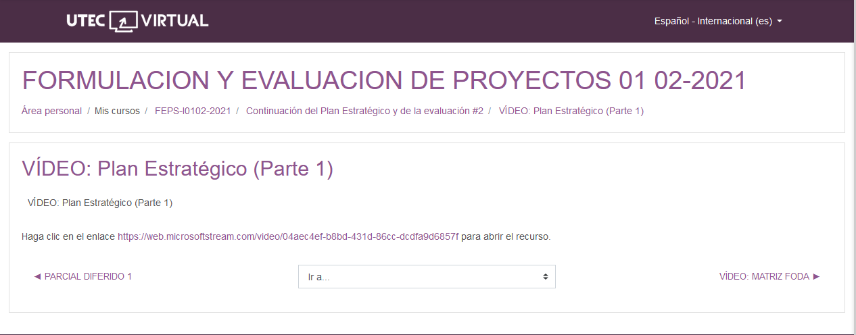

<https://web.microsoftstream.com/video/04aec4ef-b8bd-431d-86cc-dcdfa9d6857f>